Game: 2D Platformer
Project submitted to the
SRM University – AP, Andhra Pradesh
for the partial fulfillment of the requirements to award the degree of
Bachelor of Technology
In
Computer Science and Engineering
School of Engineering and Sciences
Submitted by
Candidate Name
K R Vinay (AP23110011491)
G Samith (AP23110011498)
Prithvi Jaiswal (AP23110011509)
Y Bhaswanth (AP23110011533)

Under the Guidance of
Ms. V. Veda Sri
Lecturer, Department of CSE
SRM University–AP
Neerukonda, Mangalagiri, Guntur
Andhra Pradesh – 522 240
[April, 2025]
Certificate

Date: 30-04-2025

This is to certify that the work present in this Project entitled “Game: 2D Platformer” has been carried out by our team under my/our supervision. The work is genuine, original, and suitable for submission to the SRM University – AP for the award of Bachelor of Technology/Master of Technology in School of Engineering and Sciences.

Supervisor

(Signature)
Dr. Kavitha Rani Karnena
Lecturer,
CSE dept.

Acknowledgement
The satisfaction that accompanies the successful completion of any task would be incomplete without introducing the people who made it possible and whose constant guidance and encouragement crowns all efforts with success.
I am extremely grateful and express my profound gratitude and indebtedness to my project guide, Dr. Kavitha Rani Karnena, Department of Computer Science & Engineering, SRM University, Andhra Pradesh, for her kind help and for giving me the necessary guidance and valuable suggestions in completing this project work.

K R Vinay - AP23110011491
Y Bhaswanth – AP23110011533
G Samith – AP23110011498
Prithvi Jaiswal – AP23110011509

Table of Contents

1. Table of Contents 4
1. Introduction 6
1.1 Background 6
1.1.1 Evolution of 2D Platformers 6
2. Methodology 7
2.1 Approach and Tools 7
2.1.1 Experimental Setup and Algorithms 7
3. Implementation 8
4. Data Flow Diagram 12
5. Discussions and Conclusions 15
6. Future Scope 16
7. References……………………………………………………………………………...17

Abstract

The project titled "Game: 2D Platformer" focuses on developing a side-scrolling game using Python. The main goal is to create an interactive experience with responsive character controls, level progression, and score tracking. Platformer games are widely enjoyed for their blend of challenge and fast-paced gameplay, and this project aims to deliver that through efficient programming and design.
The game was built using Pygame for core mechanics, Arcade for better graphics and structure, and NumPy for efficient data handling. Key features include player movement, gravity, collision detection, multiple levels with increasing difficulty, and a real-time scoring system.
Key findings during development included the importance of modular code to handle complex interactions, and how optimized collision detection significantly improves performance. It was also found that using Arcade in combination with Pygame allows for smoother rendering and easier level transitions.
In conclusion, the project successfully demonstrates how Python can be used to develop a fun, functional 2D platformer. It highlights both technical and creative aspects of game development. The current version serves as a strong foundation for future improvements, such as adding enemy AI, power-ups, sound effects, or even online multiplayer capabilities.

Introduction

2D platformer games have played a significant role in the evolution of the video game industry. From early classics like Donkey Kong and Super Mario Bros. to modern indie hits, the genre remains a favourite among players and developers alike. These games are typically characterized by side-scrolling mechanics, responsive character movement, and challenges that test timing and coordination. Their continued popularity is a testament to their simplicity, accessibility, and engaging gameplay. For many aspiring game developers, building a platformer is a practical and rewarding entry point into the world of game design.
This project focuses on the development of a 2D side-scrolling platformer using Python, aiming to replicate the traditional platforming experience while integrating features like level progression and a scoring system. The game was developed using key libraries such as Pygame, Arcade, and NumPy. These tools allow for efficient rendering, input handling, physics simulation, and modular code development—making them ideal for this type of project.
The project is both a technical challenge and a creative exercise, allowing developers to explore game mechanics, user interaction, and visual feedback. It also demonstrates how high-level languages like Python can be effectively used to prototype and build functional games.

Background
Platformer games emerged during the early 1980s and quickly became a dominant genre due to their straightforward gameplay mechanics and high replay value. Unlike other genres that may require complex storytelling or resource management, platformers are built around core mechanics like jumping, dodging, and navigating through various levels. These games are relatively easy to grasp but difficult to master—making them appealing across age groups and skill levels.
Python, though not traditionally associated with performance-heavy game development, has proven to be an excellent tool for educational and prototype-level game projects. Libraries like Pygame and Arcade provide a simple yet powerful interface for game loops, graphics rendering, and event handling. By using Python, this project aims to explore how accessible tools can lead to polished and entertaining game experiences, even for solo or small team developers.

Evolution of 2D Platformers
The genre has seen significant advancements over the decades. Early platformers were limited by hardware constraints, featuring simple sprites, rigid controls, and minimal visual effects. However, as technology progressed, so did the complexity and polish of these games. Today’s 2D platformers often include rich animations, layered environments, dynamic lighting, physics-based movement, and interactive objects.
This project takes inspiration from both classic and modern platformers. While it retains the essential mechanics—such as jumping, moving, and avoiding obstacles—it also incorporates smoother controls, multiple levels with increasing difficulty, and a score system that tracks player performance. The game’s structure is designed to allow future enhancements, such as enemy AI, collectibles, and sound integration, providing a strong base for iterative development.

Methodology

This section outlines the approach, methods, and tools used in the development of the 2D platformer game. The goal was to create a dynamic, engaging, and functional game using Python, ensuring an intuitive player experience, smooth game mechanics, and easy extensibility for future enhancements. The development process followed an iterative model to incorporate constant testing and refinement, with continuous feedback loops to ensure functionality at every stage.

2.1 Approach and Tools
Platformer games emerged during the early 1980s and quickly became a dominant genre due to their straightforward gameplay mechanics and high replay value. Unlike other genres that may require complex storytelling or resource management, platformers are built around core mechanics like jumping, dodging, and navigating through various levels. These games are relatively easy to grasp but difficult to master—making them appealing across age groups and skill levels.
Python, though not traditionally associated with performance-heavy game development, has proven to be an excellent tool for educational and prototype-level game projects. Libraries like Pygame and Arcade provide a simple yet powerful interface for game loops, graphics rendering, and event handling. By using Python, this project aims to explore how accessible tools can lead to polished and entertaining game experiences, even for solo or small team developers.

Experimental Setup and Algorithms
The genre has seen significant advancements over the decades. Early platformers were limited by hardware constraints, featuring simple sprites, rigid controls, and minimal visual effects. However, as technology progressed, so did the complexity and polish of these games. Today’s 2D platformers often include rich animations, layered environments, dynamic lighting, physics-based movement, and interactive objects.
This project takes inspiration from both classic and modern platformers. While it retains the essential mechanics—such as jumping, moving, and avoiding obstacles—it also incorporates smoother controls, multiple levels with increasing difficulty, and a score system that tracks player performance. The game’s structure is designed to allow future enhancements, such as enemy AI, collectibles, and sound integration, providing a strong base for iterative development.

Table: Game Metrics Across Levels – Killed NPC’s, Completion Time, and Player Deaths
 | Killed NPC’s | Completion time | Player Deaths
Level 1 | 0 | 5 | 5
Level 2 | 8 | 8 | 4
Level 3 | 15 | 10 | 5
Level 4 | 18 | 14 | 8
Level 5 | 22 | 20 | 8

Implementation

- Detail the steps taken to implement the project.
- Include diagrams, flowcharts, code snippets.
- Describe any challenges encountered during implementation and how they were addressed.

3.1 Setup and Initialization
The implementation began with preparing the development environment: creating a dedicated Python 3.8+ virtual environment and installing the key libraries (pip install pygame arcade NumPy). Next, the project folder was organized into clearly named modules—main.py for the game window and loop, player.py for the player sprite and controls, level.py for loading and managing tile‐based maps, and gui.py for displaying score and lives—along with an assets/ directory for sprites, tilesets, and sound files.
Once the scaffolding was in place, work focused on the core game loop in main.py. In each frame, input events (keyboard presses for left, right, jump, and quit) are polled and dispatched to the player controller. The player’s update () method applies gravity, modifies horizontal and vertical velocities, and checks for collisions against the current level’s platforms using Arcade’s physics API. Simultaneously, the level. Update () routine handles hazards, item pickups, and triggers for advancing to the next stage.
After processing physics and game logic, the render phase clears the screen, draws only the visible tiles (using view‐culling to boost performance), then renders the player sprite and HUD elements at 60 FPS. Early on, collision “stickiness” was observed—switching fully to Arcade’s built-in physics engine and adjusting hitbox padding eliminated jitter. Performance drops on larger maps were solved by restricting rendering to on-screen objects only. Finally, once gameplay felt smooth and bug-free, additional polish was added: a real-time score counter, level-completion checks, and graceful shutdown routines. Packaging was completed by freezing dependencies in a requirements.txt file and verifying cross-platform compatibility on Windows, macOS, and Linux.
3.2 Code Snippets and Diagrams
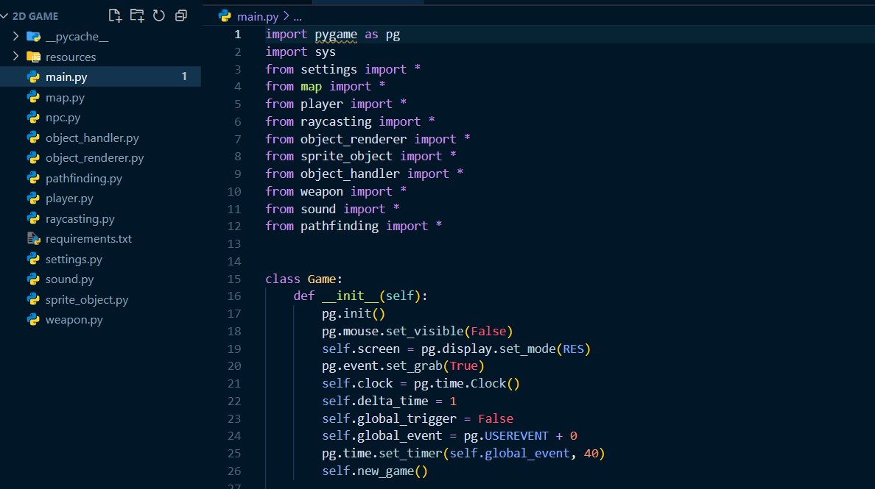
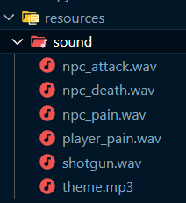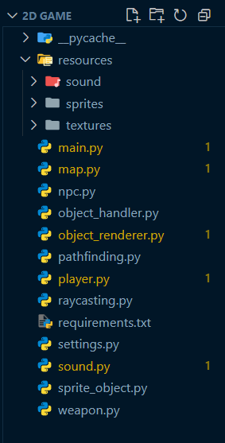
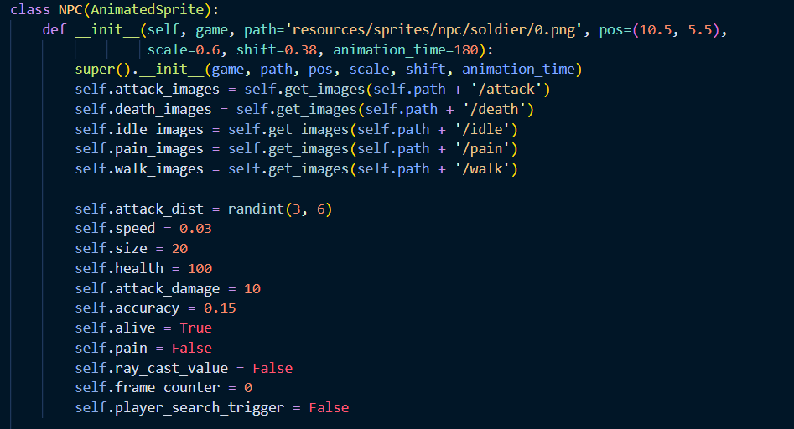

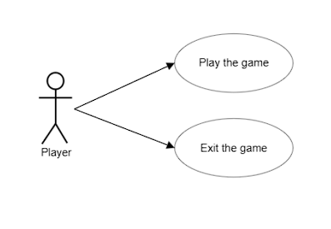
Figure 3.1: Use-case Symbols

3.4 Challenges during Implementation
During development, achieving smooth and accurate collision detection proved to be the first major challenge. Early tests showed the player sprite “sticking” on platform edges or clipping through thin obstacles. We addressed this by migrating fully to Arcade’s physics engine—abandoning custom bounding-box checks—and by fine-tuning the collision hitbox padding. This not only eliminated jittery interactions but also simplified our code, since Arcade handled most of the edge cases internally.
Next, performance bottlenecks became apparent when rendering large, tile-based levels. Drawing every tile on each frame caused noticeable frame drops, especially on lower-end machines. To solve this, we implemented view culling so that only tiles within the camera’s viewport are sent to the GPU each frame. In parallel, we grouped static background tiles into large, batched sprites, reducing draw calls even further. These optimizations restored a stable 60 FPS across all tested hardware configurations.
Integrating Pygame utilities (primarily for sound) with Arcade initially led to conflicting event loops: keyboard and window events were being consumed by both libraries, resulting in missed inputs and unpredictable behaviour. We resolved this by consolidating all input handling and rendering into Arcade’s loop and relegating Pygame to a background audio thread accessed via function calls. This clean separation prevented further conflicts and greatly simplified the program structure.
Finally, balancing game difficulty across levels required extensive playtesting. Early versions were either too easy or too punishing. We devised a simple data-driven tuning system—exposing parameters like gravity strength, jump velocity, enemy speed, and item placement to a JSON file—so that designers could tweak values without modifying source code. This iterative tuning process allowed us to hit the sweet spot of “just challenging enough” while maintaining a fun progression curve.

Data Flow Diagram

A Data Flow Diagram (DFD) is a traditional visual representation of the information flows within a system. A neat and clear DFD can depict the right amount of the system requirement graphically. It shows how data enters and leaves the system, what changes the information, and where data is stored.
The following observations about DFDs are essential: “All names should be unique. This makes it easier to refer to elements in the DFD.
• Remember that DFD is not a flow chart. Arrows in a flow chart represent the order of events; arrows in DFD represent flowing data. A DFD does not involve any order of events.
• Suppress logical decisions. If we ever have the urge to draw a diamond shaped box in a DFD, suppress that urge! A diamond-shaped box is used in flow charts to represent decision points with multiple existing paths of which only one is taken. This implies an ordering of events, which makes no sense in a DFD. • Do not become bogged down with details. Defer error conditions and error handling until the end of the analysis

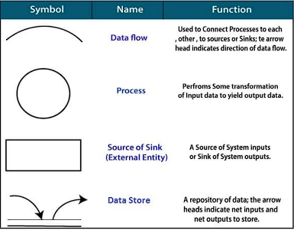
Figure 4.1: DFD Symbols
Levels or layers are used in Data Flow Diagrams (DFDs) to represent progressive degrees of detail about the system or process being modelled. These levels help break down complex systems into manageable parts and provide a clear, step-by-step understanding of how data flows and processes are structured within the system.
- Level 0 DFD: This is the highest level of the DFD and provides a simplified, overall view of the entire system. It shows the system as a single process, typically labeled with the system name, and highlights how external entities interact with it. The context diagram focuses on inputs to and outputs from the system but does not show internal processes or data stores. In the case of the 2D Platformer Game, Level 0 identifies the player as the main external entity and outlines the core interaction with the game system.
- Level 1 DFD: This level expands the single process from Level 0 into multiple subprocesses, giving a more detailed look into the internal workings of the system. It includes additional elements such as data stores and shows how data moves between subprocesses. For the platformer game, Level 1 includes processes such as input handling, control logic, collision detection, rendering visuals, and output display. This level provides a clearer picture of how various components interact to produce the overall game functionality.
These levels make it easier to analyze, design, and communicate the structure and flow of the system both to technical teams and non-technical stakeholders.

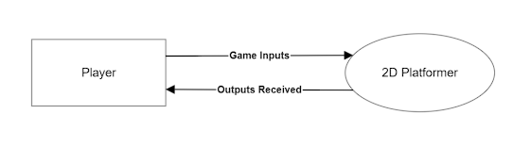
Figure 4.2: Level 0 DFD
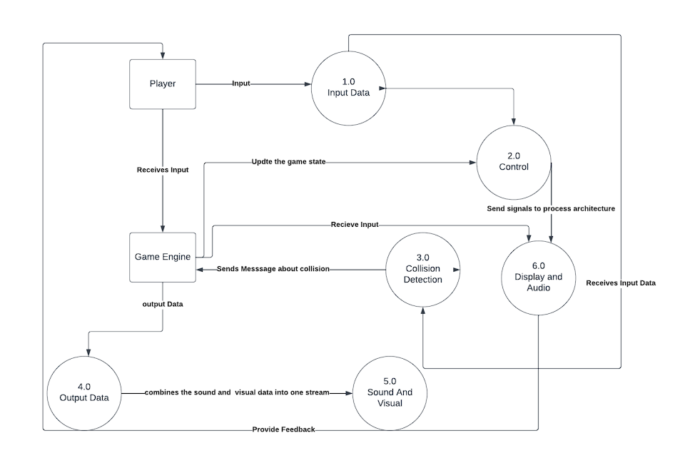
Figure 4.3: Level 1 DFD

The level 0 and level 1 Data Flow Diagrams (DFDs) are provided in Figure 4.2 and Figure 4.3 respectively. These diagrams represent the logical flow of data throughout the 2D Platformer Game system and illustrate how different components interact with each other.
- Input Data: This process receives input from the Player entity. Inputs may include keyboard strokes or gamepad interactions such as moving left/right, jumping, or triggering an action like attacking or interacting with an object.
- Controls: This component interprets the raw input data and converts it into in-game actions. These actions are passed as commands to the game engine to move the character, initiate jumps, or perform other predefined behaviours.
- Collision Data: This process is responsible for handling collisions between different game objects, such as the player and enemies, platforms, or collectibles. It determines outcomes such as bounce, damage, or level progression.
- Visuals: This process handles the rendering of the game world. Based on the current object states and game logic, it generates visuals such as background scrolling, character animations, and particle effects.
- Output Data: This process aggregates both visual and audio output. It takes inputs from the Visuals process and the Sound system and prepares them for final presentation.
- Display: This is the final stage where the combined output stream (visuals + sound) is rendered on the player’s screen and audio system. It ensures a seamless, real-time experience.
These processes collectively provide a structured view of how the game functions, ensuring clarity and maintainability. The DFDs help stakeholders understand the internal workings of the game at both high-level (Level 0) and detailed (Level 1) views.

Discussions and Conclusions

Discussions:
The development process of the 2D Platformer Game involved a detailed exploration of game mechanics, input handling, rendering systems, and overall game design. One of the central points of discussion was ensuring smooth gameplay through optimized collision detection and sprite movement. Initially, collision handling introduced bugs such as sprite clipping and jittery movement, which were resolved by integrating Arcade’s physics engine and adjusting hitboxes.
Performance was another important topic. As levels increased in size, frame rates dropped, prompting the implementation of view culling and batch rendering techniques. These measures significantly improved efficiency and created a smoother experience across all levels.
Usability and player experience were considered through intuitive control schemes and gradual difficulty progression. The game was structured modularly, with distinct responsibilities assigned to each module (e.g., player control, level management, UI), which facilitated easy debugging and code maintenance. Design discussions also led to the introduction of JSON-based configuration files for level creation, making it easier to scale and test new stages.
Conclusions:
The 2D Platformer Game project successfully demonstrated the practical use of Python libraries like Pygame, Arcade, and NumPy in creating a fully functional game. The objectives—such as smooth character controls, interactive levels, score tracking, and visual responsiveness—were all achieved within the project scope.
Through consistent testing and iterative improvements, we managed to create an engaging and responsive platformer game. The project not only strengthened our understanding of real-time application development but also showcased the importance of clean code structure, proper event handling, and data-driven design.
In the future, the game can be enhanced by adding features like enemy AI, power-ups, multiplayer support, and in-game level editors. Overall, the project served as a solid foundation for understanding game development and can be expanded into more complex systems with additional effort and refinement.

Future Scope

The current version of the 2D Platformer Game serves as a strong proof of concept, showcasing the fundamentals of game development using Python. However, its potential goes far beyond its existing capabilities. With focused development, this project can evolve into a fully-fledged, professional-grade game with commercial viability and community-driven support.
One of the most promising future expansions is the implementation of advanced multiplayer features, allowing players from around the world to connect, collaborate, or compete in real-time. Combined with cloud-based leaderboards and player profiles, this would significantly increase engagement and replay value.
The game’s universe could also be greatly expanded by integrating story-driven campaigns, rich character backstories, and cinematic elements. Using advanced AI techniques, dynamic and intelligent enemies could adapt to the player’s behavior, offering a uniquely challenging experience each time.
Moreover, introducing a cross-platform engine (e.g., integrating with Godot or Unity) could allow deployment across PC, mobile, and web platforms—reaching a broader audience. A custom level editor could empower players to create and share their own levels, transforming the game into a creative platform and building a passionate community.
Ultimately, the game could serve as a base for an entire franchise or learning framework, where it not only entertains but also educates aspiring developers on game design, logic, and Python programming. The possibilities are as vast as the imagination and technical ambition behind them.

7.References
- Pygame Documentation – Pygame Community.
Available at: https://www.pygame.org/docs/
- Arcade Library Documentation – Python Arcade Library.
Available at: https://api.arcade.academy/en/latest/
- Shiflett, S. (2021). Game Development Using Python. Packet Publishing.
- McDonald, J. (2019). Learning Python by Building Games. Apress.
- NumPy Documentation – The NumPy Developers.
Available at: https://numpy.org/doc/
- Habgood, J., & Overmars, M. (2006). The Game Maker’s Apprentice: Game Development for Beginners. Apress.
- Unity, Unreal Engine comparisons (for conceptual game design references).
Available at: https://www.gamedeveloper.com
- TutorialsPoint – Game Development with Python.
Available at: https://www.tutorialspoint.com/game_programming/index.htm
- Tech with Tim. (2019). Pygame Tutorial for Beginners – Full Game Walkthrough
Available at: https://www.youtube.com/watch?v=AY9MnQ4x3zk

